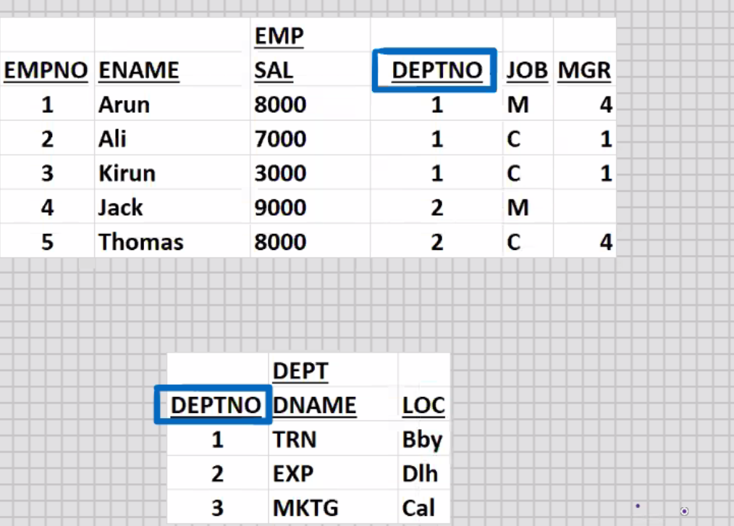

**MySql – SQL Joins**

Select deptno, sum(sal) from emp

Gropu by deptno;

**DEPTNO SUM(SAL)**

**----------- ------------------**

**1 180000**

**2 17000**

SELECT dname, sum(sal) from emp, dept

WHERE dept.deptno = emp.deptno

Group by dname;

DNAME SUM(SAL)

------------- ----------------

**TRN 18000**

**WXP 17000**

SELECT upper(dname), sum(sal) from emp, dept

Where dept.deptno = emp.deptno

Group by upper(dname)

Having sum(sal) > 10000

Order by 1;

* **TYPES OF JOINS (5) :-**

1. **Equijoin:- *Join based on equality condition**

**\*Shows matching rows of both tables**

**\*Uses:-**

**a. DNAME,ENAME**

**B. CNAME, SNAME**

**\*Most frequently used join(more than 90%), hence it is also known as Natural join**

**Dept 🡺 driving table**

**Emp 🡺 driven table**

Select dname,ename from emp, dept

Where dept.deptno = emp.deptno;

DNAME ENAME

TRN Arun

TRN Ali

TRN Kirun

EXP Jack

EXP Thomas

1. **Inequijoin(Non equi join):-**

* Join based on inequality condition
* Show non-matching rows of both the tables
* **Uses:-**

a.Exception Reports

i. Who are the employees who don’t belong to TRN.

ii. Who are the customers who have not made the payment

Select dname,ename from emp, dept

Where dept.deptno != emp.deptno;

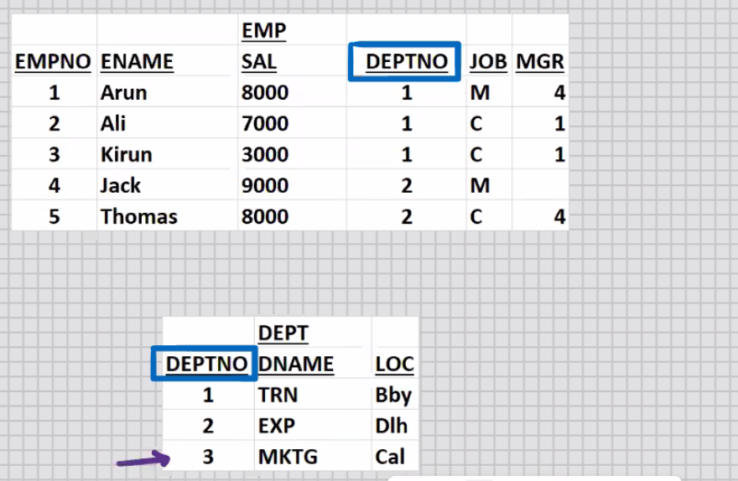

1. **Outerjoin:-**
2. **Half Outerjoin (1 Do While Loop, 1 For Loop)**
3. **Right Outerjoin**
4. **Left Outerjoin**
5. **Full Outerjoin (Nested Do While Loop):-**

* **Shows matching row of both tables plus and Non matching rows of both the tables.**
* **Union of Right OuterJoin and Left Outerjoin**

**ANSI syntax for Full Outerjoin:-**

Select dname, ename from emp full outer join dept

On(dept.deptno = emp.deptno);

**ANSI SYNTAX FOR RIGHT OUTERJOIN:-**

Select dname, ename from emp RIGHT outer join dept

On(dept.deptno = emp.deptno);

**-----------------------------------------------------------------------------------------------------**

**ANSI SYNTAX FOR LEFT OUTERJOIN:-**

Select dname, ename from emp LEFT outer join dept

On(dept.deptno = emp.deptno);

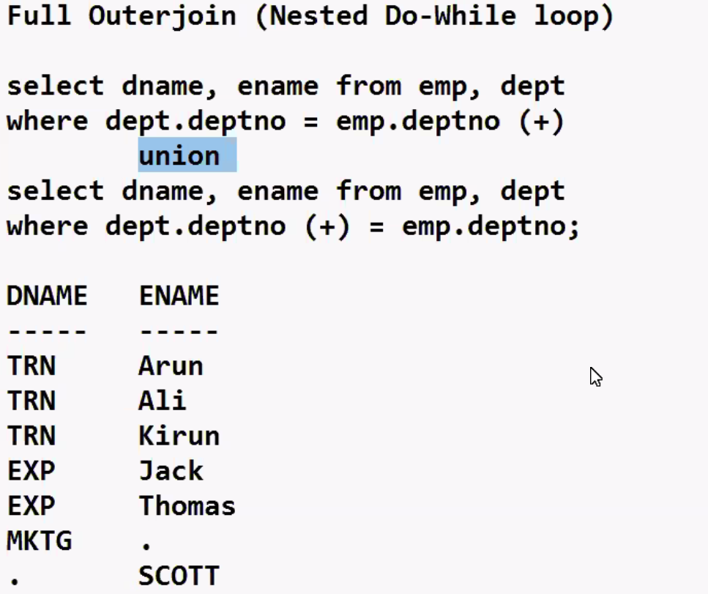

* Join with (+) sign or if you use the keyword “Outer”.
* Show matching rows of both tables. Plus

Non-matching rows of” Outer” table

* Outer table 🡺 table which is on outer side of (+) sign
* Outer table 🡺 table which is on Opposite side of (+) sign
* USES:-

1. Master-Detail

**SELECT dname, ename from emp,dept**

**WHERE dept.deptno (+) = emp.deptno;**

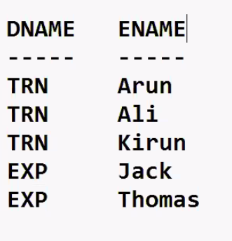

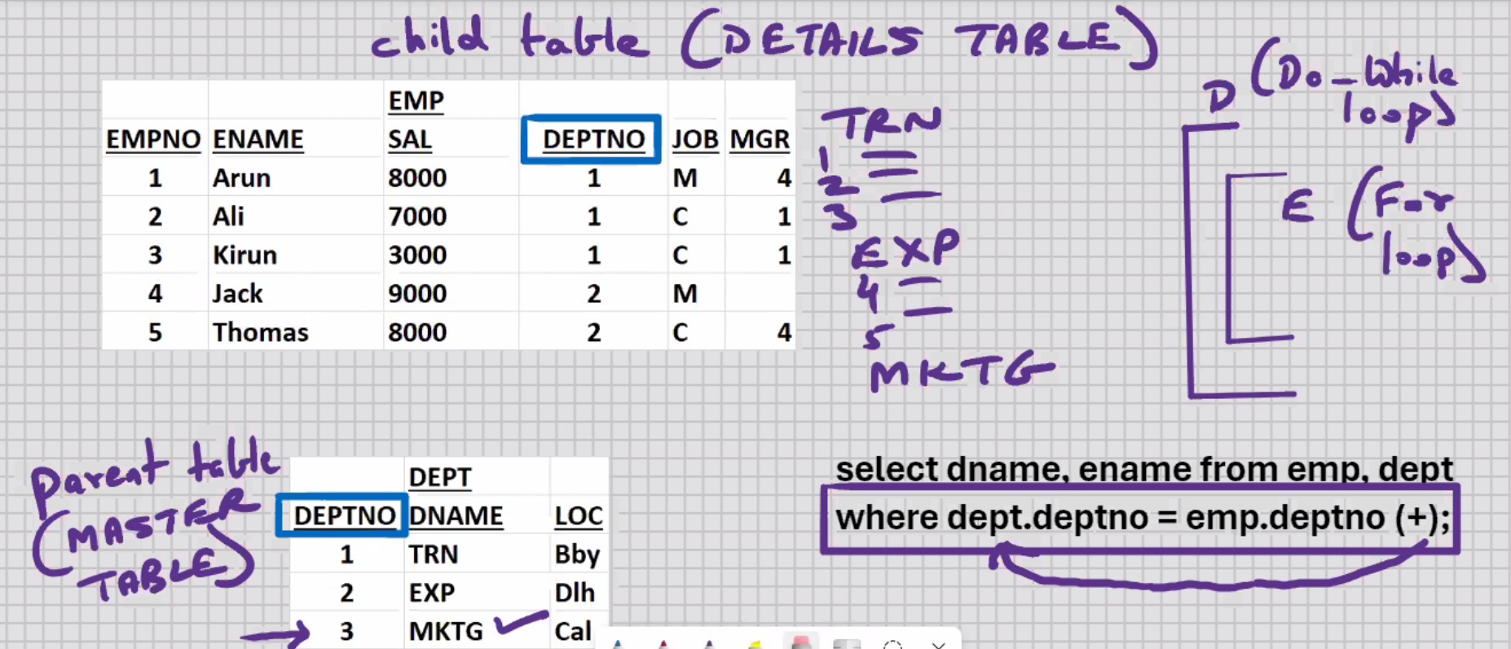

SELECT dname, ename from emp, dept

WHERE dept.deptno = emp.deptno (+);

DNAME ENAME

